ATLAS-LNF

Wire Tension Measurement system instruction manual
(preliminary version)

System description

The system uses the electrostatic method to measure MDT wire tension. It is made of a central unit and sixteen sensors (fig 1). The length of the cables connecting the central unit to the sensors is not critical (up to 15 meters of coaxial HV/signal cables can be used without system performances deterioration). Connections between tube and sensors, on the contrary, must be as short as possible and made with twisted cables to reduce crosstalk between the sensors. The system is fully operated by a PC running a Labview program through an RS232 interface.

PRECAUTIONS: the system uses a modulated high voltage square wave to excite mechanical oscillation around the wire fundamental harmonic resonance, therefore the sensor connections to the tube are under HIGH VOLTAGE during the measure.

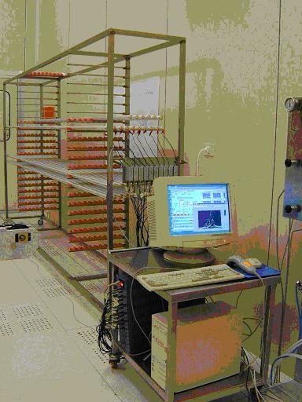

Figure 1: WTM system

Setup

Before use the system, check that the following cables are correctly connected (fig. 2,3):

- Power cord (1)
- RS232 cable (2)
- HV cables (3)
- Signal cables (4)
- Temperature sensor cable (5)

Pay attention to HV and signal cable numbering.

STEP 1: start the WTM Labview control program

Double click the WTM icon shown on the PC monitor to start the program. A Labview control panel will appear, as shown in fig. 4.

Power cord (1)
Signal cable (4)
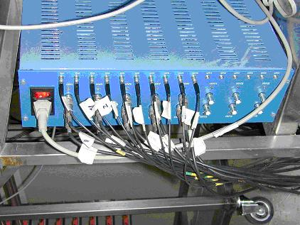
HV cables (3)

Figure 2: WTM back view

STEP 2: check the program parameters

The upper left hand side of the panel shown the parameters used for the measurements. Verify that their values correspond to those shown in fig. 5.
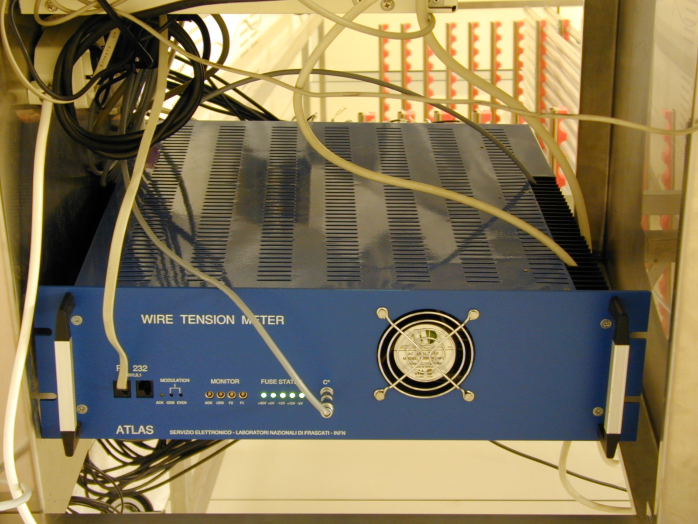
Figure 3: WTM front view
RS232 cable (2)
T sensor cable (5)

STEP 3: connect sensors to the tubes

Connect the sensors to the tubes paying attention to twisted cables polarity (the red one must be connected to the wire feed through)

STEP 4: temperature sensor positioning

The temperature sensor must be positioned next to the tubes under measure.

STEP 5: start the WTM program

Click on the Labview start program arrow to start the program; a window will appear prompting for tube codes. Insert the tube codes using the PC bar code reader. Start from the first tube (be patient; the reading procedure sometimes fails).
Check on the panel under the plot area (fig. 6) that tube number have been correctly inserted.

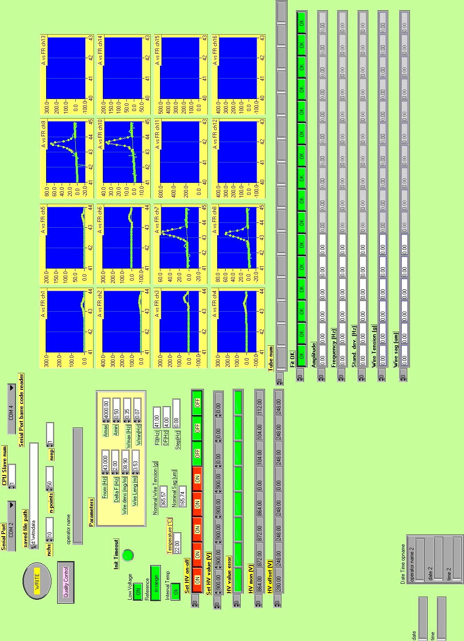
Figure 4: WTM program control panel
Figure 5: WTM program control panel (default parameters values)

Figure 6: Tube number panel

STEP 6: control diagram outputs

As soon as the measure has been completed control the fit results in the diagram area (fig. 7). An unsuccessful measure is easily identified looking at the plots (see the two plot in the third column of fig. 7). In addition the fit results are also shown in the fit panel, a red spot highlights a problem in the measure. As most of the problems are due to bad sensor connections check tube-sensors setup and start a new measure before store the measure results in the local database.

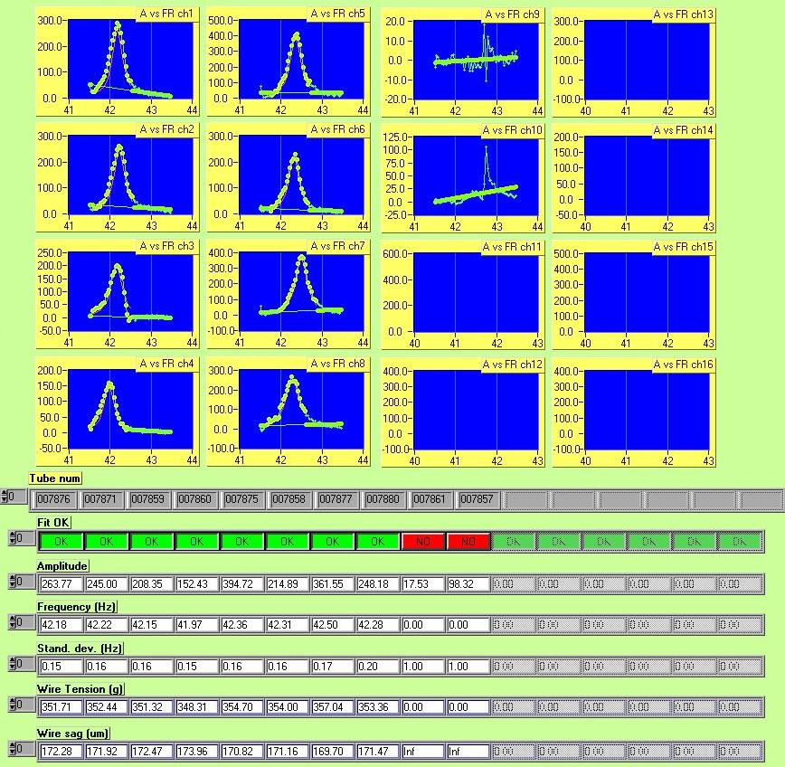
Figure 7: Plot area and measure results

