INVESTIGATION OF CHANNELING AND RELATED COHERENT PHENOMENA IN PERIODICAL STRUCTURES AT BTF – FRASCATI.

Necessary experimental conditions for channeling investigation in BTF area of LNF were created recently in the framework of tari projects 23,35.

Low emittance e+ beam was obtained using special iron collimator.
The horizontal emittance of the beam ε < 1 mm×1 mrad was achieved.
The image of collimated positron beam in 0.5 m downstream of collimator is shown in Fig.1, registered with high resolution photoemulsion detector.

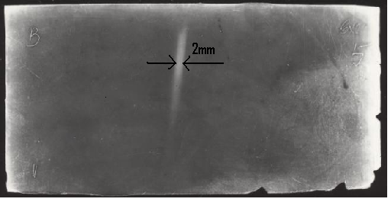

Effect of beam collimation was also registered by scintillation hodoscop detector,
placed at the end of vacuum system in 4 meters behind the collimator.

Based on simulation results and applying new type high resolution detector
one can research effect of coherent bending of e+ beam exceeded usual Coulomb scattering.

Special bent silicon samples (1mm along the beam, 2 milliradian bend) were prepared
applying new bending technique. It is planned to use these samples at first stage of coherent bending investigations.

